Worksheet 4
Student Name: Anjali kumari UID:25MCA20023
Branch: MCA(General) Section/Group:25MCA-1-A
Semester: III Date of Performance:09/09/26
Subject Name: Internet Of Things Subject Code: 25CAH-708

Aim/Overview of the practical:
Interface an Arduino Uno, Led and Buzzer with RFID reader/writer MFRC522 and register the card's UID. Write a program to check whether the card used is authorized or unauthorized.
  - If the card is authorized, then Turn ON only "Yellow Led" and buzzer will Beep twice.
  - If the card is unauthorized then Turn ON only “Blue Led" and buzzer will Beep three times.

Apparatus:
Hardware Requirements: Breadboard
MFRC 522 RFID Sensor
Buzzer Jumper wires
LED (2 pieces) Arduino Uno Board

Software requirements: Arduino IDE
Laptop

Circuit Diagram(TinkerCad):
Coding:
#include <SPI.h> #include <MFRC522.h>
// RFID pins #define SS_PIN 10
#define RST_PIN 9
// Output pins
#define YELLOW_LED 6
#define BLUE_LED 7
#define BUZZER 8
MFRC522 rfid(SS_PIN, RST_PIN);
byte authorizedUID[] = {0xA3, 0xB4, 0xC5, 0xD6};

void setup() { Serial.begin(9600); SPI.begin(); rfid.PCD_Init();
pinMode(YELLOW_LED, OUTPUT); pinMode(BLUE_LED, OUTPUT); pinMode(BUZZER, OUTPUT);
digitalWrite(YELLOW_LED, LOW); digitalWrite(BLUE_LED, LOW); digitalWrite(BUZZER, LOW);

Serial.println("RFID Reader Ready..."); Serial.println("Place your RFID card near the reader.");
}

void loop() {
// Check whether a new card is present if (!rfid.PICC_IsNewCardPresent()) { return;
}
// Read the card
if (!rfid.PICC_ReadCardSerial()) { return;
}
// Print UID Serial.print("Card UID: ");

for (byte i = 0; i < rfid.uid.size; i++) { if (rfid.uid.uidByte[i] < 0x10) { Serial.print("0");
}
Serial.print(rfid.uid.uidByte[i], HEX); Serial.print(" ");
}
Serial.println();
// Check whether UID is authorized if (checkUID()) {
Serial.println("AUTHORIZED CARD");
// Yellow LED ON digitalWrite(YELLOW_LED, HIGH); digitalWrite(BLUE_LED, LOW);

// Beep twice
for (int i = 0; i < 2; i++) { digitalWrite(BUZZER, HIGH); delay(200);

digitalWrite(BUZZER, LOW); delay(200);
}
delay(2000);
// Turn LED OFF digitalWrite(YELLOW_LED, LOW);
} else {
Serial.println("UNAUTHORIZED CARD");
// Blue LED ON digitalWrite(YELLOW_LED, LOW); digitalWrite(BLUE_LED, HIGH);
// Beep three times
for (int i = 0; i < 3; i++) { digitalWrite(BUZZER, HIGH); delay(200); digitalWrite(BUZZER, LOW); delay(200);
}
delay(2000);
// Turn LED OFF digitalWrite(BLUE_LED, LOW);
}
// Stop communication with current card rfid.PICC_HaltA(); rfid.PCD_StopCrypto1();
delay(500);
}
bool checkUID() {

// First check UID length
if (rfid.uid.size != sizeof(authorizedUID)) { return false;
}

// Compare every byte
for (byte i = 0; i < rfid.uid.size; i++) {

if (rfid.uid.uidByte[i] != authorizedUID[i]) { return false;
}
}
return true;
}

6.Output: 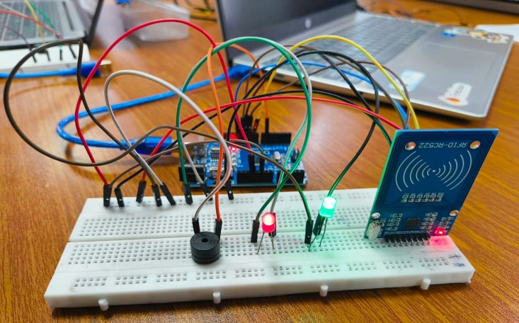
FIG1: Interfacing of RFID WITH BUZZOR AND LED ON ARDINOUNO

Learning outcomes (What I have learnt):
  - RFID sensor and its components.
  - Interfacing of Arduino uno board with RFID sensor.
  - Differences between RFID card and reader, in the context of active and passive elements.

